Cadence Health

Final Report

Mobile Application

Version 1.0, 03/11/14

Table of Contents

1. Introduction - Daniel 3

2. Project Planning - Daniel 3

3. Requirements and Analysis - Nick 3

4. Design - Nick 3

5. Implementation - Nick 3

6. Learning Outcomes – Daniel, Nick 3

7. Conclusion - Daniel 3

8. RTM - Nick 3

# Introduction - Daniel

# Project Planning - Daniel

# Requirements and Analysis – Nick

***Font size 11, Spacing 1.1, Font Times New Roman

*****Make sure to add informal dialog*****

***** I am not really interested in a rehash of the documents you have given me already. I want you to review all aspects of your project and reflect on what you did, why you did it, what worked and what should have been done differently.

You may include information/diagrams from other documents to make your discussion more informative. Assume that someone was reading the document to discover what you had been up to for the past 3 months and could also see why you drew the conclusions that you did. Don't assume they have read all the other documents.

The requirements and analysis of the Clients needs was complex at first but was easier to see grasp once the feasibility study was completed. This allowed us to focus on what the essentials were and what the Clients expects to be done. It became apparent that the potential health impacts and positive changes to people’s eating habits was a major motivator for the Client to implement something new and easy to use.

The decision was made by the Client to have a mobile application developed, so that it would be widely available to people and easy to use and understand, a key property of any good application.

It was immediately apparent that an APP for and Android phone would best suit the ease of use and universality that was needed.

Several alternative solutions were looked at from no solution to a fully-fledged Android App with everything proposed by the Client. Each were looked at and were studied, but ultimately a simpler version of the initially proposed application was decided upon for a range of reasons: time frame was limited, expertise was limited, background knowledge and information about ORAC (for Team) was limited. The team should have how ever chosen a slightly more scaled down solution, as the complexity of the tasks was not immediately apparent and quickly grew immensely. There should have also been more direct contact with the client to ensure this was communicated more effectively, along with a more realistic idea of what was feasible. But this leaves room for further increments and versions, and allows the application to grow as parts are finished and implemented sucessfullly.

# Design – Nick

The Design of the APP was crucial because of our Clients need for it to be user friendly and simple to use. It also had to present the information in and easy to understand and simple manner. This made certain alternative designs impractical and others more suitable.

The mobile APPLICATION is designed to be a standalone APPLICATION running on an Android smart phone, which will allow users to better track and manage their meals so they can become healthier and improve their wellbeing.

The main feature of the APP is to allow users to take and image and tag the main ingredients and have an ORAC rating generated from these Tags. Another main feature of the APP is to allow the USERS to look at previously saved and tagged meals, and allow them to see the details for each meal.

They will also be able to search meals uploaded by other USERS to the web database, so that they can get a better idea of healthy meals and what other people are doing. This would make the APP more social and interactive for the USERS.

However, even with these implemented perfectly the APP cannot exist without context and this is important when on a mobile device. This is because the context can change and vary between USERS and must be taken into account.

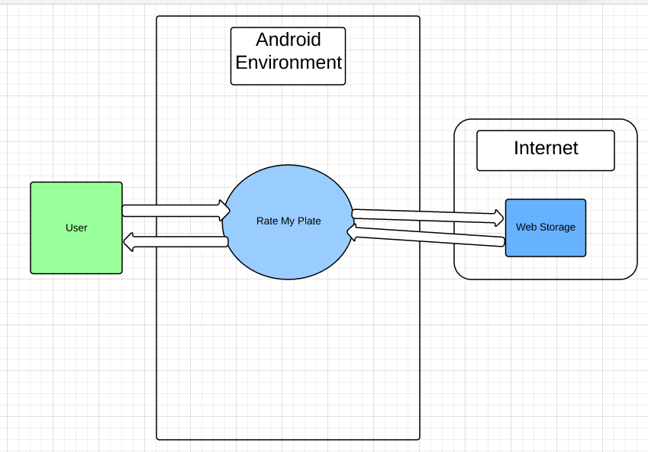

The APP runs on and Android smartphone and runs within this environment. The USER interacts with the phone and the APP, but not directly with the web database. The APP communicates and takes care of operations between the web database and phone. This was chosen as it limits the possibility for human error and makes the Query process much fast and efficient.

Mention Database (SQLite) Both local and remote server (4.2 Storage/Persistent Data Strategy)

# Implementation – Nick

For the implementation of the Application the team decided that an AGILE approach was best suited. This was because it: met the requirements of the unit, allowed prototypes to be rapidly tested and feedback given on each, a preview of the final application before completion, rapid feedback from the Client. This was crucial as meeting and checking the Application met the Client’s needs was key in the implementation.

To start with the implementation was slow as requirements were gathered but once an understanding of what was required was built up, the development moved along more quickly.

Every week there were two meetings to discuss what was to be done in the week coming and one later in the week to go over any issues we had completing various tasks. There was also regular attendance by the Client every 2 weeks to see how progress was going. This was very beneficial during the implementation, as things could be changed and seen in the next implementation. This led to better client feedback and minimal design changes as the app progressed.

Followed Agile development

-list of changes

-what we would do differently

-if we would change anything

-ongoing work (running sever etc)

-back end

_update app and keep running

-marketing e.g. app store, website for client?

MVC approach

4.3 Trade offs and Choices

# Learning Outcomes – Daniel, Nick

Still have no clue

# Conclusion - Daniel

# RTM - Nick